

The University of Azad Jammu and Kashmir, Muzaffarabad
Name | Jawahir Ali
Course Name | Computer Architecture and Logic Design
Submitted to | Engr. Sidra Rafique
Semester | 2nd
Session | 2024-2028
Roll No | 2024-SE-34
Lab No | 04

Department of Software Engineering

De Morgan’s law

Procedure:
- At first construct the circuits shown in Boolean laws.
- Check if the laws are valid. Give truth tables for each law.
- Apply various combinations of inputs as shown in the truth table and observe the conditions of LEDs.

(A + B)' = (AB)’…………(i)
(AB)’ = A’ + B’…………...(ii)
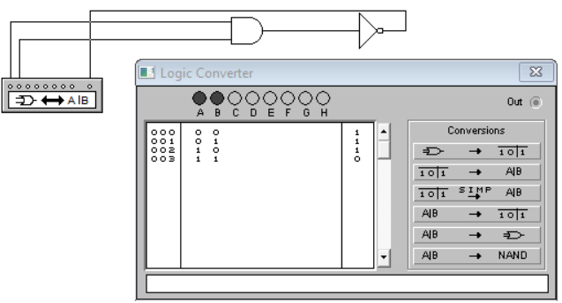

. .…is equivalent to …
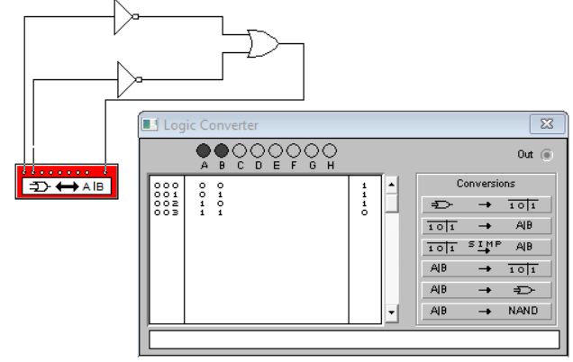

(AB)’ = A’ + B’
(1 * 0)’ = 1’ + 0’
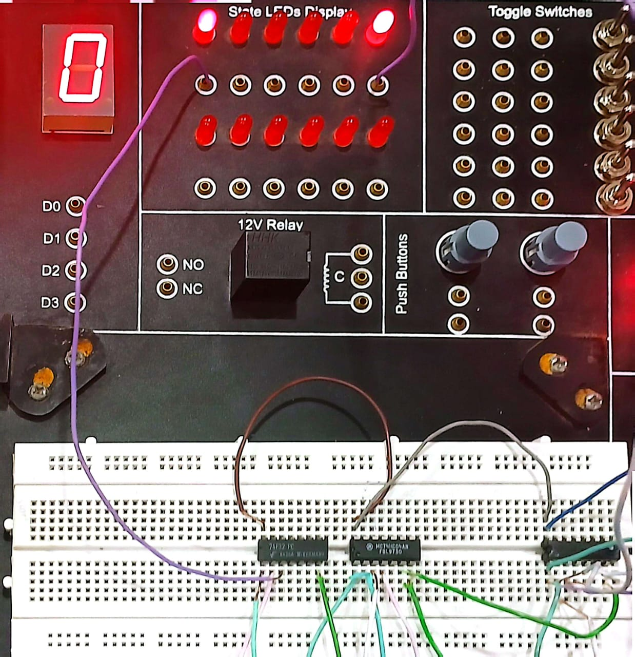
(A + B)' = (AB)’
(1 + 1)’ = 1’ * 0’
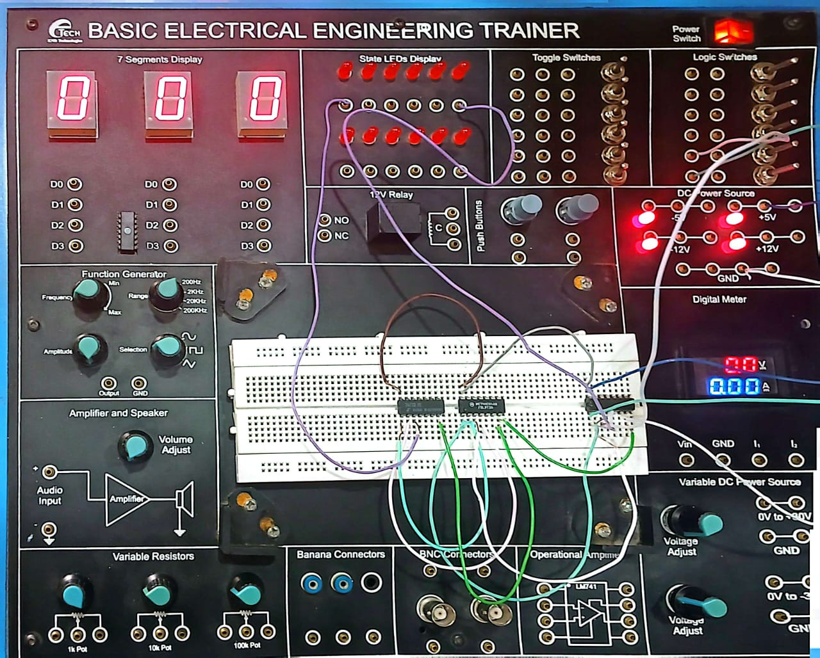

(AB)’ = A’ + B’
(0 * 1)’ = 0’ + 1’
